Dr Sivakumar and Dr Gude
Patient Newsletter
October 2020

Flu Special

We are now in the middle of the Flu vaccination season and we felt it might be a good time to explain some of the things that are different this year.
When are our vaccines ordered?
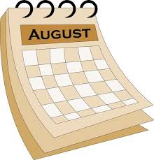
Our flu vaccinations were ordered in September last year. We ordered enough to vaccinate all patients that were eligible for the vaccine at that time.
We pay for these vaccines and if we don’t use the vaccine by the end of February, we have to throw them away.

Is it true that healthy 50-64 year olds or Shielding patients should be given a Flu Vaccination?
This year, the Government announced that vaccines will be available for ‘extra’ groups of patients (those ad between 50 and 64 and Shielding patients and their families).
Unfortunately we haven’t received the vaccines from NHS England yet. We expect to receive these end of November beginning of December.

In the meantime, we first have to vaccinate the patients that we ordered for in September 2019. These are:
- Adults aged 65 and over
- People with some medical conditions including diabetes, heart failure and asthma
- People who were required to shield from coronavirus and their household
- Pregnant women
- Children aged between two and three
- Health and social care workers

Please click https://www.nhs.uk/conditions/vaccinations/flu-influenza-vaccine/

FLU CLINICS BY APPOINTMENT ONLY
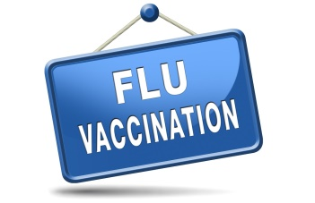
This year, our flu vaccine deliveries are 1st October 2020.
Normally at a flu clinics, we vaccinate one patient every minute. This year, due to Covid, we have to schedule 3 minutes per patient so that we can maintain social distancing and don’t have too many patients in the building at any time.
You can book an appointment on line using mygpapp www.mygp.com/ You can also request an appointment by sending a AskmyGP message to the receptionist. If you do not have internet access, or a mobile phone, please ring on 01942 878711.
Types of Vaccines
There are two different types of vaccine. One for Under 65’s and one for Over 65’s.

When attending for your FLU appointment:
- Those displaying symptoms of COVID-19, or who are self-isolating because they are confirmed COVID-19 cases or are contacts of suspected or confirmed COVID-19 cases, should not attend until they have recovered and completed the required isolation period.
- If you have any symptoms of COVID-19, please do not enter the Surgery, as you will not be able to have the flu vaccine
- Please wear a face mask/covering when attending for a flu vaccine. If you are exempt, we ask if you are not able to wear for the short time that you will be in the practice, if you could make a 10 appointment, for another day. (not in a flu clinic)
- Only the patient having the flu jab will be allowed to enter the Surgery, unless they’re accompanied by a carer or parent/guardian
- Please only use the car park if you have a blue badge or if you have difficulty with mobility.
- Please arrive on time for your appointment.
Child Flu Vaccine for age 2 – 3 years old
Please contact the Surgery to book an appointment for children aged 2 or 3 on 31 August 2020 – that is, children born between 1 September 2016 and 31 August 2018. Please read the following guidelines https://www.nhs.uk/conditions/vaccinations/child-flu-vaccine/
Finally, thank you for being so patient with us this year, we need to make sure that we don’t have too many patients in the practice at any time so that we can maintain social distancing and we must do everything we can to keep you all safe.
Thank you for your understanding.

